**MINISTRY OF EDUCATION AND TRAINING**

**FPT UNIVERSITY**

**DOCUMENT REPORT**

Capstone Project Document

**VN Habit Tracker**

|  |  |
| --- | --- |
| **Group 3** | |
| **Group members** | Lưu Thành Đạt - SE61124  Nguyễn Quang Tuyến - SE62069  Nguyễn Hữu Thắng - SE62447  Phạm Thanh Tùng - SE61628 |
| **Supervisor** | Lại Đức Hùng |
| **Ext. Supervisor** | N/A |
| **Capstone Project code** | VHT |

- Ho Chi Minh city, September 14th 2018

Table of Contents

Definitions, Acronyms, and Abbreviations 5

**A.** **Introduction** 6

1. Project Information 6

2. Introduction 6

3. Current Situation 6

4. Problem Definition 6

5. Proposed Solution 6

5.1 Feature functions 7

5.2 Advantages and disadvantages 7

6. Functional Requirements 7

7. Role and Responsibility 8

**B.** **Software Project Management Plan** 9

1. Problem Definition 9

1.1. Name of this Capstone Project 9

1.2. Problem Abstract 9

1.3. Project Overview 9

2. Project organization 12

2.1. Software Process Model 12

2.2. Roles and responsibilities 13

2.3. Tools and Techniques 14

3. Project Management Plan 15

3.1. Software development life cycle 15

3.2. Phase Detail 16

3.3. All Meeting Minutes 17

4. Coding Convention 17

**C.** **Software Requirement Specification** 19

1. User Requirement Specification 19

1.1 Guest Requirement 19

1.2 User Requirement 20

1.3 Admin Requirement 20

2. System Requirement Specification 21

2.1 External Interface Requirement 21

2.2 System Overview Use Case 22

3. Software System Attribute 23

3.1. Usability 23

3.2. Reliability 23

3.3. Availability 23

3.4. Security 23

3.5. Maintainability 23

3.6. Portability 23

3.7. Performance 23

4. Conceptual Diagram 24

**D.** **Software Design Description** 25

1. Design Overview 25

2. System architecture design 26

2.1. Web Application architecture description 26

3. Component Diagram 27

4. DetailedDescription 29

4.1. Class diagram 29

4.2. Class Diagram Explanation 30

4.3. Interaction Diagram 33

4.4. Activity diagram 35

List of tables

Table 1: Roles and Responsibilities 9

Table 2 : Hardware Requirement for Server 12

Table 3 : Hardware Requirement for Mobile 12

Table 4 : Software requirements 13

Table 5 : Roles and responsibilities 14

Table 6: Tools List 14

Table 7: Technique List 14

Table 8: Software Development Life Cycle Detail 15

Table 9: Phase 1: Infrastructure 16

Table 10: Phase 3: Web service 17

Table 11: Phase 4: Mobile app 17

# Definitions, Acronyms, and Abbreviations

|  |  |
| --- | --- |
| **Name** | **Definition** |
| VHT | VN Habit Tracker |
|  |  |

# **Introduction**

## Project Information

* Project name: **VN Habit Tracker**
* Abbreviation: **VHT**
* Product Type: **Web app & Mobile app**
* Start Date: **September 10th 2018**

## Introduction

Habits are routine behaviors done on a regular basis. They are recurrent and often unconscious patterns of behavior and are acquired through frequent repetition. Many of these are unconscious as we don’t even realize, we are doing them.

Good habits are hard to develop when we use the typical tactic of trying to pump up our motivation to overcome our psychological resistance. Research has shown that motivation is an ineffective factor or creating lasting behavior change. Fortunately, we have also will build an excellent alternative, which is called VHT. It will let us tunnel right through the resistance barrier.

First thing is to track habits! You can also track recurring behavior that you want to keep under control. This tracker can be made for daily use, so you get a very clear overview of all your good and bad habits. By keeping a habit tracker, you are more conscious of your behaviors. You know actually what you are doing, more importantly, what not, what you should do. Without this tracker it can be very easy to believe you are indeed doing everything you want, but in the meantime, secretly, you are not. The tracker is a tool to transform your goals into good habit.

## Current Situation

* Everyday our lives are governed by habit. These habits are the little routines and small ways of doing things.
* Most people are unaware or are only slightly aware that they’re doing them.
* VHT helps you to set goals, keep track of your habits and tackle your bad habits.

## Problem Definition

* **Disadvantages:**
  + Vietnamese users do not have the official application for tracking habit.
  + Customer easily give up on using.

## Proposed Solution

Our proposed solution is to build an application called “VN Habit Tracker” to resolve the current problems. The application collects (in real-time) all habits from customer. Moreover, it specifically helps them to track their habits daily, weekly and monthly. This application will motivate them by showing the notification and reminder which depend on their setting. Customer can check their currently process. We also design the app which has statistics that helps customer to see their efforts.

VHT system is an app application with following functions:

### Feature functions

* + Plan habits with an easy-to-use interface.
  + Habits fit into a number of different schedules, including specific times or days.
  + View stats in a number of different ways, with different data point.
  + Reminders.
  + Make sure no habit is forgotten with daily reminders.
  + Data Export.
  + Export your data to Excel or Numbers (CSV) and chart your progress.
  + Interactive Notifications.
  + Complete or snooze a habit right from the notification banner.
  + Weekly Targets.
  + Set how many days a week you would like to complete a habit.
  + Notes.
  + Write or dictate notes to capture all details of a habit. Great for exercise routines and daily journals.
  + Skip Functionality.
  + Going on vacation or taking a day off? Skip habits without breaking your chain.
  + Report.

### Advantages and disadvantages

These are advantages and disadvantages of current situation:

* **Advantages:**
  + - Customer will be easy to understand.
    - Friendly interface.
    - Motivate customer to change their bad habits.
    - VHT saves times and space for customer.
  + **Disadvantages:**
    - Advertising strategy difficulty of application.

## Functional Requirements

Function requirements of the system are listed as below:

Add habits:

* + Choose habit: add a bad habit you want to reform or build a good one to improve.
  + Name habit: name that habit.
  + Choose period: choose daily, weekly, monthly.
  + Set goal: set up the goal you want to archive.
  + Choose group: set that habit belongs to which group that you want.
  + Adjust reminder: set time for the app to remind you.
  + Write description: write something that can motivate you.

Show statistics: show the statistics to display the chart in the present or in the past.

Adjust setting:

* + Set goal.
  + Set reminder.

Adjust filter: display the result in the form that customer want.

* + Choose goal period.
  + Choose goal type.
  + Choose goal values.

Adjust chosen habit:

* + Edit chosen habits.

## Role and Responsibility

|  |  |  |  |  |
| --- | --- | --- | --- | --- |
| **No** | **Full Name** | **Role** | **Position** | **Contact** |
| 1 | Lại Đức Hùng | Project Supervisor | Supervisor | Hungld5@fe.edu.vn |
| 2 | Lưu Thành Đạt | Developer | Leader | Datltse61124@fpt.edu.vn |
| 3 | Nguyễn Quang Tuyến | Developer | Member | Tuyennq62069@fpt.edu.vn |
| 4 | Nguyễn Hữu Thắng | Developer | Member | Thangnhse62447@fpt.edu.vn |
| 5 | Phạm Thanh Tùng | Developer | Member | Tungptse61628@fpt.edu.vn |

Table 1: Roles and Responsibilities

# **Software Project Management Plan**

## Problem Definition

### Name of this Capstone Project

* **Official name**: VN Habit Tracker
* **Vietnamese name**: Ứng dụng theo dõi, cải tiến thói quen cho người Việt.
* **Abbreviation**: VHT

### Problem Abstract

Currently, in Viet Nam, the majority of people use smartphones every day. However, there is not a specific application for Vietnamese people to create habits, manage daily habits and track habits. The existing tracking habit applications are from foreign developer and thus may not really applicable for Vietnamese users. So we have to find the best convenient way to make our application simplest and easy to use for anyone.

To solve this particular problem, we decided to provide an application that helps users do that*.* VHT will help users to create habits, group habits, and prompt users to implement those habits. Create a goal for the user to try to achieve that habit over time and manage the statistics of the user’s system habits.

### Project Overview

#### Current Situation

Below are the problems encountered in this project:

* **User Habit:** people do not have a habit to set habit and manage habit by an application.
* **User:** easily give up when they depressed, unmotivated to continue a habit.
* Currently there is no application dedicated to Vietnamese.
* **Server crash**: The user's data will be lost when the server crashes. Because all data is stored on the server.
* **Interface**: user easy-to-use interface in VHT’s application.

#### The Proposed System

According to the survey of Vietnamese users, we find that most Vietnamese do not have a habit of scheduling, do not schedule what week they will do. So our solution now is to create an application specifically for Vietnamese users to improve and create their habits.

We build a system that is always maintained so that users can log in and use it on their mobile applications anytime, anywhere.

To solve the problem of creating habits and improving the habits of Vietnamese users, we need to know the Vietnamese people, what makes them do not create their daily routine.

Our system consists of two main systems: website and mobile applications. On the website, administrators manage users and statistical habits of Vietnamese. For mobile applications, we allow users to create and manage their habits, and we also receive feedback from Vietnamese users.

##### *Web Application*

Web application consists of three main parts:

* For user:
  + View general data.
  + Export data to excel.
* For administrator:
  + Manage accounts.

Besides, website application also provides an API interface for two mobile applications to retrieve, update data from mobile applications.

##### *Mobile Application*

The mobile applications included functions as below:

* User:
  + Create habits.
  + Manage habits.
  + Group habits.
  + Habits statistic.
  + Complete or snooze a habit.
  + Export data.

#### Boundaries of the System

* This application is built on the habits of Vietnamese. Our main target is helps them to set goals, keep track of habits and tackle bad habits.
* VN Habit Tracker which deployed this application must set up devices, includes:
  + Daily reminders.
  + Data export to number and chart progress.
  + Interactive notifications.
  + Weekly targets
  + Notes details of a habit.
* The completed product includes:
  + Website application.
  + Android mobile application.

#### Future Plans

With further research and development, the system can apply the following features:

* + Extend and create community using VHT.
  + Develop new features to set and remind users to create a habit: real time, remind by location..v..v..
  + Combined with smart watch and external devices to manage and message users.
  + Development Environment with VHT.

##### *Hardware requirements*

* **For web application server**

|  |  |  |
| --- | --- | --- |
| Windows | Minimum Requirements | Recommended |
| Internet Connection | Cable, Wi-Fi (4 Mbps) | Cable, Wi-Fi (8 Mbps) |
| Operating System | Window Server 2008 R2 | Window Server 2012 R2 |
| Computer Processor | Intel® Xeon ® 1.4GHz | Intel® Xeon ® Quad Core |
| Computer Memory | 2GB of RAM | 4GB of RAM or more |

Table 2 : Hardware Requirement for Server

* **For Mobile**

|  |  |  |
| --- | --- | --- |
| Android | Minimum | Recommended |
| Internet Connection | Wi-Fi or 3G (1 Mbps) | Wi-Fi or 3G (8 Mbps) |
| Operating System | Android 4.4.2 | Android 6.0.0 |
| Mobile Processor | Cortex-A7 Dual-Core 1.3GHz | Cortex-A7 Dual-Core 1.3GHz |
| Mobile Memory | 1GB of RAM | 2GB of RAM or more |

Table 3 : Hardware Requirement for Mobile

##### *Software requirements*

|  |  |  |
| --- | --- | --- |
| Software | Name / Version | Description |
| Operating system | Window Server 2012 R2 | Operating system and platform for development |
| Environment | Java | Specification for developing web application |
|  |  |  |
| IDE | IntelliJ IDEA, Android Studio v2.1 | Used for implement website and Android Mobile Application. |
| Design Model tool | Star UML v2.5.1 | Used for creating modal and diagrams. |
| DBMS | Microsoft SQL Server 2014 | Used to create & manage the database for system |
| Document storage | Trello | Used for storing document |
| Store and manage source code | Git Hub | Used to store all source code |
| Web browser | Chrome or above | Testing browser |

Table 4 : Software requirements

## Project organization



### Software Process Model

The software process model used in developing the VHT project is based on the Water Fall model. We choose this model because of the following reason:

* The features of this product is strongly connected, therefore, a solid architect and clear requirement need to be setup in order to un the project smoothly.
* The requirements are not supposed to be changed rapidly.

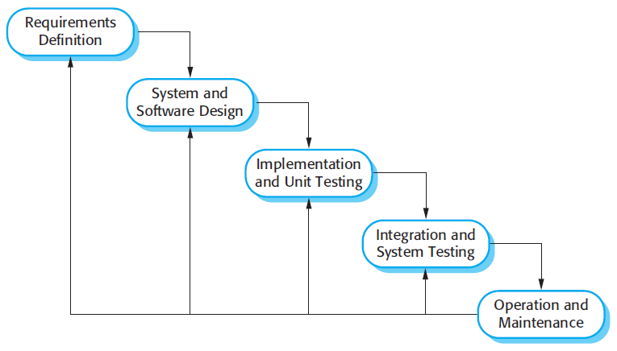

Figure 1 : Waterfall model

Reference: Page 30, chapter 2, Software process model, SOFTWARE ENGINEERING 9th Edition, by Ian Sommerville.

### Roles and responsibilities

|  |  |  |  |
| --- | --- | --- | --- |
| No | Full name | Role in Group | Responsibilities |
| 1 | Lại Đức Hùng | Supervisor, Project Manager | * Specify user requirements * Control the development process * Give out technique and business analysis support |
| 2 | Lưu Thành Đạt | Team leader, B.A, Developer, Tester | * Managing process * Designing database * Clarifying requirements * Prepare documents * GUI design * Create test plan * Coding * Testing |
| 3 | Nguyễn Hữu Thắng | Team member,  B.A, Developer,  Tester | * Designing database * Clarifying requirements * Prepare documents * GUI design * Create test plan * Coding * Testing |
|  | Phạm Thanh Tùng | Team member,  B.A, Developer,  Tester | * Designing database * Clarifying requirements * Prepare documents * GUI design * Create test plan * Coding |
| 4 | Nguyễn Quang Tuyến | Team member,  B.A, Developer,  Tester | * Clarifying requirements * Prepare documents * Create test plan * Coding * Testing |

Table 5 : Roles and responsibilities

### Tools and Techniques

|  |  |
| --- | --- |
| Tool | Name / version |
| Web server | IIS |
| Development tool | IntelliJ IDEA, Android Studio |
| DBMS | SQL Server 2014 |
| Source control | Git hub & SourceTree |
| Modeling tool | Star UML v5.0.1 |
| Document tool | Microsoft Word 2016 |

Table 6: Tools List

|  |  |
| --- | --- |
| Technique | Name / version |
| Frontend | HTML5, CSS, JavaScript, Angular |
| Backend | Java, Spring Boot, Hibernate, Android |

Table 7: Technique List

## Project Management Plan



### Software development life cycle

|  |  |  |  |  |  |
| --- | --- | --- | --- | --- | --- |
| Phase | Description | Deliverables | Resource needed | Dependencies and Constrains | Risks |
| Infrastructure | - Identify and clarify overall requirements.  - Determine the system architecture.  - Build infrastructure for the project. | - Database design.  - System main structure. | 20 man-days | N/A | - Unclear project scope.  - Lack of member share of understand. |
| API services | - Identify requirements for mobile app.  - Build required API for mobile app. | - API for mobile app. | 60 man-days | - Depends on “Database Design”. | - Lack of experience. |
| Mobile apps | - Design the mobile UI  - Build mobile apps for end users and emulator. | - Complete Android Apps. | 20 man-days | - Depends on “API services”. | - Lack of experience.  - Lack of Habit Behavior knowledge |
| Web App | - Implements all web app modules.  - Design the web UI.  - Build the web app. | - Complete Web Apps. | 20 man-days | - Depends on “API services”. | - Lack of experience. |

Table 8: Software Development Life Cycle Detail

### Phase Detail

#### Phase 1: Infrastructure

|  |  |  |
| --- | --- | --- |
| Task | Description | Author |
| 1. Assessment | - Determine requirements.  - Determine requirements for System and API. | * DatLT * ThangNH * TuyenNQ * TungPT |
| 2. Selection | - Determine system architecture: Java Web & Android.  - Determine software design pattern: Repository & Service.  - Determined all core functions. | * DatLT * ThangNH * TuyenNQ * TungPT |
| 3. Development | - Create the main structure of project. | * DatLT * ThangNH * TuyenNQ * TungPT |
| 4. Review | - Review all completed works and presentation.  - Create sprint backlog. | * DatLT * TungPT |

Table 9: Phase 1: Infrastructure

#### Phase 3: Web service

|  |  |  |
| --- | --- | --- |
| Task | Description | Author |
| 1. Assessment | - Determine requirements for Web service. | * DatLT * ThangNH * TuyenNQ * TungPT |
| 2. Selection | - Determine all functions according to requirements of Web service. | * DatLT * ThangNH * TuyenNQ * TungPT |
| 3. Development | - Create API for mobile app based on functions on the web app. | * DatLT * ThangNH * TuyenNQ * TungPT |
| 4. Review | - Review all completed works and presentation.  - Create sprint backlog. | * DatLT * ThangNH * TuyenNQ * TungPT |

Table 10: Phase 3: Web service

#### Phase 4: Mobile app

|  |  |  |
| --- | --- | --- |
| Task | Description | Author |
| 1. Assessment | - Determine requirements for System and Mobile app. | * DatLT * ThangNH * TuyenNQ * TungPT |
| 2. Selection | - Determine all functions according to requirements of Mobile app. | * DatLT * ThangNH * TuyenNQ * TungPT |
| 3. Development | - Implement all the functions based on the designed UI and the provided API. | * DatLT * ThangNH * TuyenNQ * TungPT |
| 4. Review | - Review all completed works and presentation.  - Create sprint backlog. | * DatLT * TungPT |

Table 11: Phase 4: Mobile app

### All Meeting Minutes

Meeting minutes are contained in folder “Meeting minutes”.

### Coding Convention

This “Coding Convention” is using for develop project in both Java web admin and Android application:

* Naming Conventions:
* Folders (Java web admin): folders name are always unique and written in lowercase.

Ex: customer, servlet, sample…

* Packages (Android application): packages/folders name are always unique and written in lowercase.
* Classes/Interfaces: classes or interfaces should be noun, name using Pascal case, in mixed case with the first letter of each internal word capitalized.

Ex: User, ImageSession, CustomerDAO…

* Methods: methods should be verb, name using Camel case, in mixed case with the first letter lower case, with the first of each internal word capitalized.

Ex: run (), crawlNew (), getSearchResults () …

* Variables: name using Camel case, in mixed case with the first letter lower case, with the first of each internal word capitalized. Variable names should not start with underscore _ or dollar sign $ characters, even though both are allowed.

Ex: count, myVariable, isValidated…

* Constants: constants should be all uppercase with words separated by underscores.

Ex: MAX_VALUE, GET_SEARCH_RESULT

* Comment:
* All source files should begin with a comment that lists the class name, description, date, author:

/*

* Class name

*

* Description

*

* Date

*

* Author

*/

* All methods should begin with a comment that lists the method name, description, date, author:

/*

* Method name

*

* Description

*

* Date

*

* Author

*/

* Comment code is 2 slashes “//”
* Comment to explain code need 4 slashes “////”
* Block comment used to provide description of files, methods, structures and algorithms.
* Indentation: Four spaces should be used as the unit of indentation
* Declarations: one declaration per line. Do not put different types on the same line

Ex: int minValue;

# **Software Requirement Specification**

* + - 1. User Requirement Specification
  1. Guest Requirement

Guest is a person who doesn’t have access to the system. Guest can use some functions in the system. To use all functions, guest must login. These are some functions that guest can use:

• Login.

* Register.
  1. User Requirement

User is a guest who logged into the system with user’s role. There are some functions that user can use:

* Manage habit

+ View habit

+ Delete habit

+ Edit habit

+ Add habit

+ Check times

* Manage group

+ Add group

+ Delete group

+ Edit group

* Manage settings

+ Sort habit

+ Set reminders

+ Feedback and contact

* View statistics
* Logout
  1. Admin Requirement

Admin is the person who manages the system, a super user of system. There is some functions admin can use:

* Manage user

+ View user

+ Reset password

* Manage feedback

+ View feedback

+ Reply feedback

1. System Requirement Specification
   1. External Interface Requirement
      1. *User Interface*

* General requirement for graphic user interface is the GUI should be simple, clear, intuitive, and reminiscent.
* The interface design is an iterated process includes design, sketching and user assessment.
  + 1. *Hardware Interface*
* Smartphone, desktop, laptop or tablet has the ability to connect to the internet.
* The system will use the standard hardware and data communications resources of a standard computer.
  + 1. *Software Interface*
* Run with Chromes (v60 or higher), Firefox (v46.1 or higher)
* The screen must bigger than 1024x768.
* Mobile application: Android studio (version 3.1.4), Genymotion (version 2.12.2).
  + 1. *Communication Protocol*
* Using HTTP/HTTPS protocol.
  1. System Overview Use Case

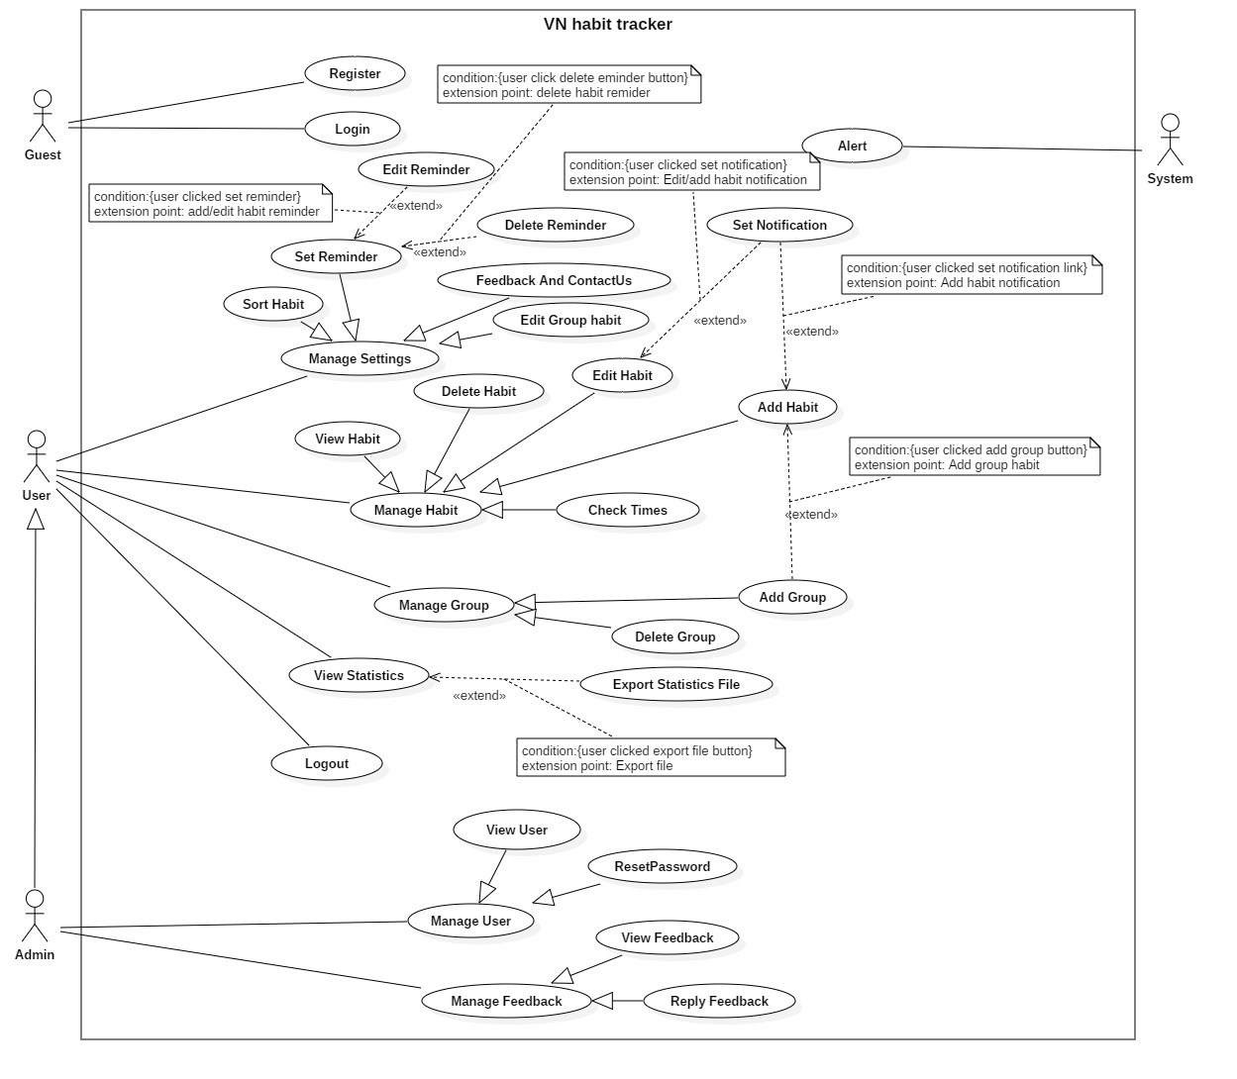

*Figure 2- System Overview Use Case*

1. Software System Attribute
   1. Usability

* Provide a convenient way to interact with system.
* Screen layout and navigation are clear and easy to use.
* Interface are simple and clear, user can easy to manage habit and group.
* Icons that indicate the actions should be easy to understand and users will not meet any troubles to recognize the feature of application.
  1. Reliability
* The number of sending notification failure is 1 time per 200 notifications.
* The data should be backed up every day.
  1. Availability
* Website available 24/24.
* User connects to internet to login into the application.
* User uses offline after login and connect internet to push data to the server.
  1. Security
* Private: Each role of user has a specific permission to interact with the system.
* Only admin can manage user and feedback of user.
  1. Maintainability
* The code is easy to maintain and upgrade.
* Maintain the whole system every 1 months.
* Accidental problem will be resolved within acceptable time.
  1. Portability
* The website is running on Windows 7 or above.
* The mobile application running on a device with API 23 or above.
  1. Performance
* All requests are handled in maximum time of 5 seconds.

1. Conceptual Diagram

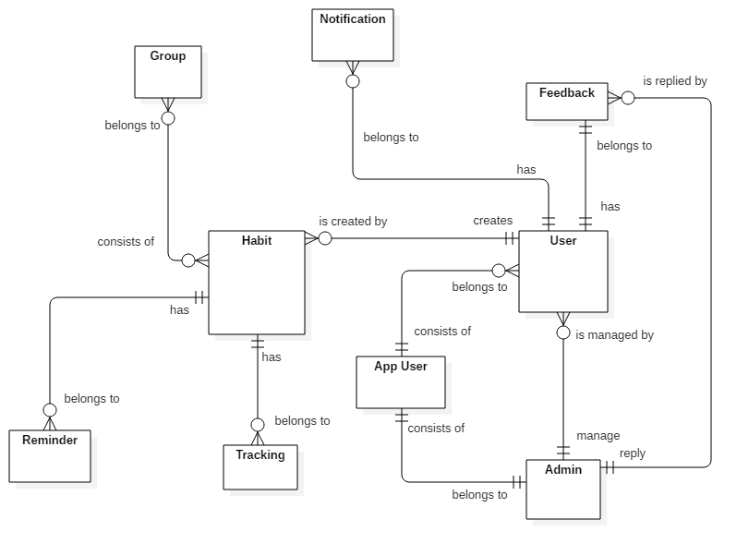

*Conceptual diagram*

***Data Dictionary***

|  |  |
| --- | --- |
| Entity Data dictionary: describe all content of all entities | |
| Entity Name | **Description** |
| App User | Abstract entity describes a user in system |
| User | Contain the user information. |
| Admin | Contain the admin information. |
| Feedback | Contain the feedback information. |
| Habit | Contain the habit information. |
| Notification | Contain the notification information. |
| Tracking | Contain the vehicle information. |
| Reminder | Contain the reminder information. |
| Group | Contain the group information |
|  |  |
|  |  |

1. **Software Design Description**
2. Design Overview

- This document describes the technical and user interface design of MSSC System. It includes the architectural design, the detailed design of common functions and business functions and the design of database model.

- The architectural design describes the overall architecture of the system and the architecture of each main component and subsystem.

- The detailed design describes static and dynamic structure for each component and functions. It includes class diagrams, class explanations and sequence diagrams for each use cases.

- The database design describes the relationships between entities and details of each entity. - Document overview:

* + Section 2: gives an overall description of the system architecture design.
  + Section 3: gives component diagrams that describe the connection and integration of the system.
  + Section 4: gives the detail design description which includes class diagram, class explanation, and sequence diagram to details the application functions.
  + Section 5: describe screens design.
  + Section 6: describe a fully attributed ERD.
  + Section 7: describe algorithms.

1. System architecture design

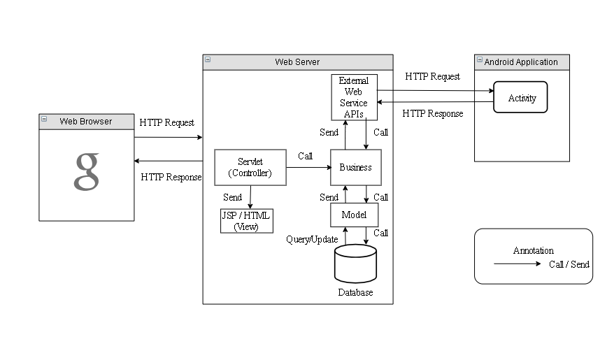

*Figure 9 System architecture design*

* 1. Web Application architecture description

In Web Application, the system is developed under J2EE MVC architecture style. We choose this architecture for Web application because of in scope of the 4 - member team, MVC architecture makes it easier to split the big project into small modules and make it easier to assign each module for members in our team.

This project follows MVC architecture with following components:

* **Servlet (Controller)** is the parts of the application that acts like event handler to handle user interaction. Typically, the controller reads data from a request and calls appropriate Business’s method, then selects view to return to user.
* **JSP/HTML (View)** is the parts of the application that handles the display of the data. The selection of View is under control of Controller.
* **Business** is the parts of the application that do business processing to solve domain problems.
* **Model** is the parts of the application that acts like a data transfer object between the system and database.
* **Web Service** is the parts of the application that acts like an event handler for web and mobile communication via REST method.

1. Component Diagram

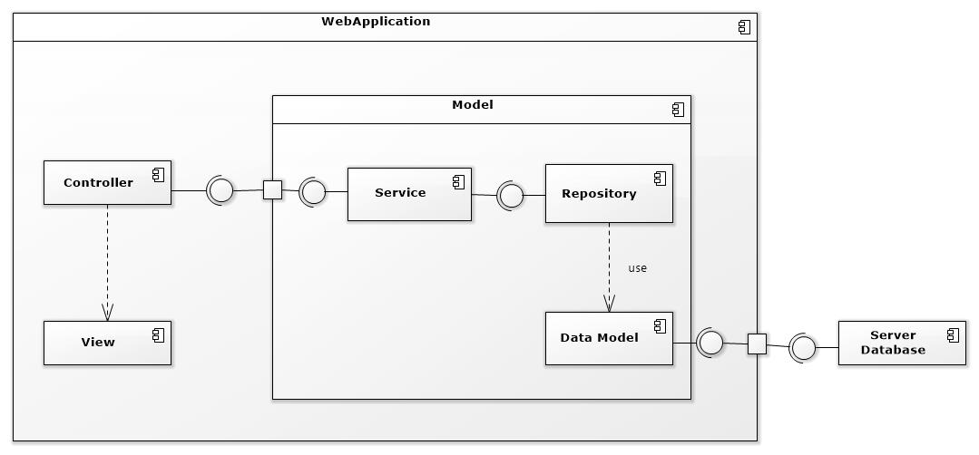

Figure 1: Component Web Diagram

| **Components Dictionary: Describes components** | |
| --- | --- |
| Web Apllicaiton | Component to controll the system and process request from mobile. Contains sub component: Model, Web Service, Controller. |
| View | Component that display data |
| Controller | Component of website to handle request from web |
| Service | Component to handle business logic of Website component |
| Repository | Component that communicate with database |
| Data Model | Component that do the interaction between the system and database. Contain sub components: Repository and Service |
| Server Database | Component that store data of system |

Table 1- Components Web Dictionary

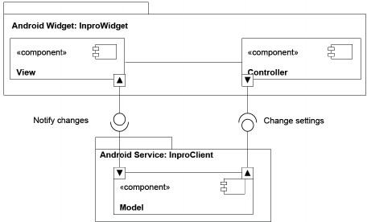

Figure 2: Component Android Application Diagram

| **Components Dictionary: Describes components** | |
| --- | --- |
| Android Apllicaiton | Component to controll the system and process request from mobile. Contains sub component: Model, Android Service, Controller. |
| View | Component that display data. |
| Controller | Component of application to handle request from application. |
| Android Service | Component to handle business logic of application component. |
| Model | Component that do the interaction between the system and database. Contain sub components: Repository and Service |

Table 2- Components Application Dictionary

1. DetailedDescription
   1. Class diagram

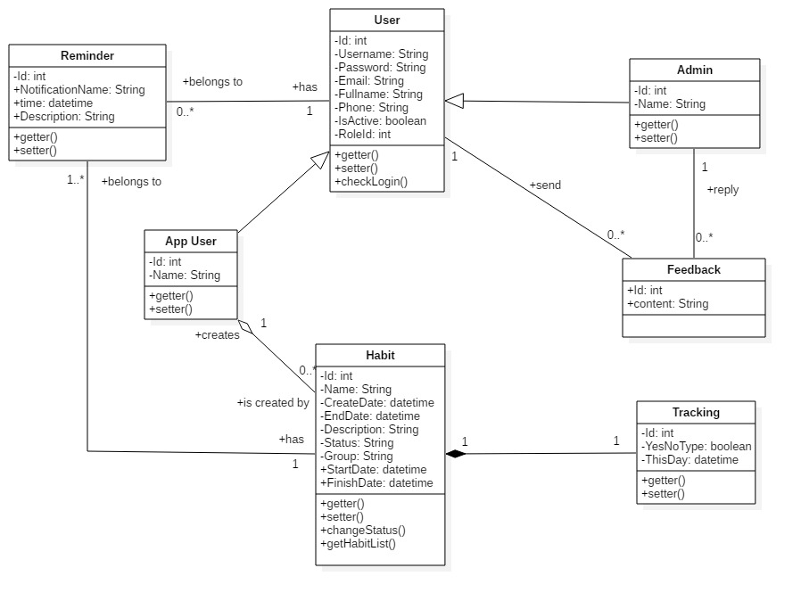

*Figure 11 Class Diagram*

|  |  |  |
| --- | --- | --- |
| CLASS DICTIONARY: DESCRIBE CLASS | | |
| Class Name | **Mapping column with Conceptual diagram** | **Description** |
| App User | N/A | Contains the app user information |
| Admin | Admin | Contains the admin information |
| User | User | Contains the user information |
| Habit | Habit | Contains the habit information |
| Reminder | reminder | Contain the reminder information |
| Feedback | Feedback | Contains the feedback information |
| Tracking | Tracking | Contains the Tracking information |

* 1. Class Diagram Explanation
     1. *App User*

|  |  |  |  |
| --- | --- | --- | --- |
| **Attribute** | **Type** | **Visibility** | **Description** |
| id | Integer | Private | Unique identifier of a user |
| username | String | Private | User’s username |
| name | String | Private | User’s name |
| password | String | Private | User’s password |
| fullName | String | Private | User’s full name |
| phone | String | Private | User’s phone |
| email | String | Private | User’s email |
| roleId | Integer | Private | Id of user’s role |
| isActive | Boolean | Private | User’s status |
| **Method** | **Return Type** | **Visibility** | **Description** |
| getter | Attribute type | Public | Get value of attribute |
| setter | Void | Public | Set value for attribute |
| checkLogin | Boolean | public | Check user login the system |

* + 1. *User*

|  |  |  |  |
| --- | --- | --- | --- |
| **Attribute** | **Type** | **Visibility** | **Description** |
| id | Integer | Private | Unique identifier of a user |
| username | String | Private | User’s username |
| password | String | Private | User’s password |
| fullName | String | Private | User’s full name |
| phone | String | Private | User’s phone |
| email | String | Private | User’s email |
| roleId | Integer | Private | Id of user’s role |
| isActive | Boolean | Private | User’s status |
| **Method** | **Return Type** | **Visibility** | **Description** |
| getter | Attribute type | Public | Get value of attribute |
| setter | Void | Public | Set value for attribute |

* + 1. *Admin*

|  |  |  |  |
| --- | --- | --- | --- |
| **Attribute** | **Type** | **Visibility** | **Description** |
| id | Integer | Private | Unique identifier of a admin |
| username | String | Private | Admin’s username |
| name | String | Private | Admin’s name |
| password | String | Private | Admin’s password |
| fullName | String | Private | Admin’s full name |
| phone | String | Private | Admin’s phone |
| email | String | Private | Admin’s email |
| roleId | Integer | Private | Id of admin’s role |
| isActive | Boolean | Private | Admin’s status |
| **Method** | **Return Type** | **Visibility** | **Description** |
| getter | Attribute type | Public | Get value of attribute |
| setter | Void | Public | Set value for attribute |

* + 1. *Habit*

|  |  |  |  |
| --- | --- | --- | --- |
| **Attribute** | **Type** | **Visibility** | **Description** |
| id | Integer | Private | Unique identifier of a habit |
| name | String | Private | Habit’s name |
| createDate | datetime | Private | Habit’s create date |
| endDate | datetime | Private | Habit’s end date |
| startDate | datetime | Private | Habit’s start date |
| finishDate | datetime | Private | Habit’s finish date |
| group | String | Private | Habit’s group |
| description | String | Private | Habit’s description |
| status | String | Private | Habit’s status |
| **Method** | **Return Type** | **Visibility** | **Description** |
| getter | Attribute type | Public | Get value of attribute |
| setter | Void | Public | Set value for attribute |
| getHabitList | List | Public | Get all habit of user |

* + 1. *Feedback*

|  |  |  |  |
| --- | --- | --- | --- |
| **Attribute** | **Type** | **Visibility** | **Description** |
| id | Integer | Private | Unique identifier of user |
| content | String | Private | Feedback’s content |
| **Method** | **Return Type** | **Visibility** | **Description** |

* + 1. *Reminder*

|  |  |  |  |
| --- | --- | --- | --- |
| **Attribute** | **Type** | **Visibility** | **Description** |
| id | Integer | Private | Unique identifier of the habit |
| notificationName | String | Private | Notification’s notification name |
| time | Datetime | Private | Notification’s time |
| description | String | Private | Notification’s description |
| **Method** | **Return Type** | **Visibility** | **Description** |
| getter | Attribute type | Public | Get value of attribute |
| setter | Void | Public | Set value for attribute |

* + 1. *Tracking*

|  |  |  |  |
| --- | --- | --- | --- |
| **Attribute** | **Type** | **Visibility** | **Description** |
| id | Integer | Private | Unique identifier of a habit |
| type | Boolean | Private | Tracking’s type |
| thisDay | datetime | Private | Tracking’s this day |
| **Method** | **Return Type** | **Visibility** | **Description** |
| getter | Attribute type | Public | Get value of attribute |
| setter | Void | Public | Set value for attribute |

* 1. Interaction Diagram
     1. *Add new habit*

*Summary: this diagram show process of user add new habit*

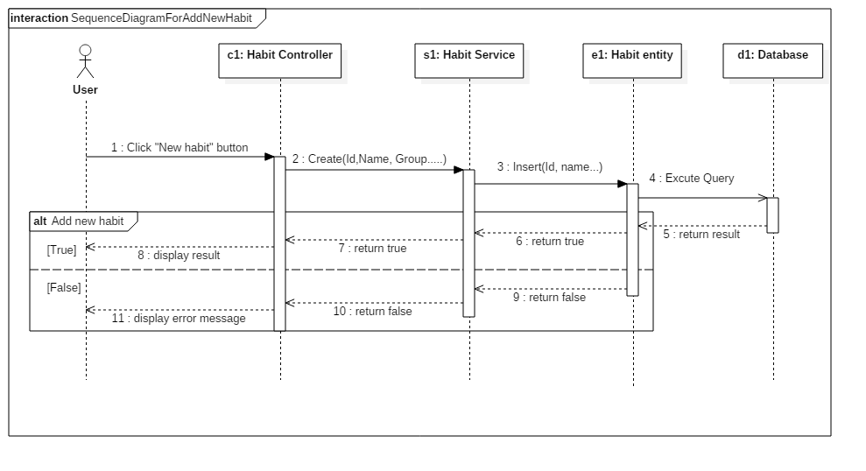

Figure - Sequence Diagram for add new habit <User>

* + 1. *Edit habit*

*Summary: this diagram show process of user edits a habit.*

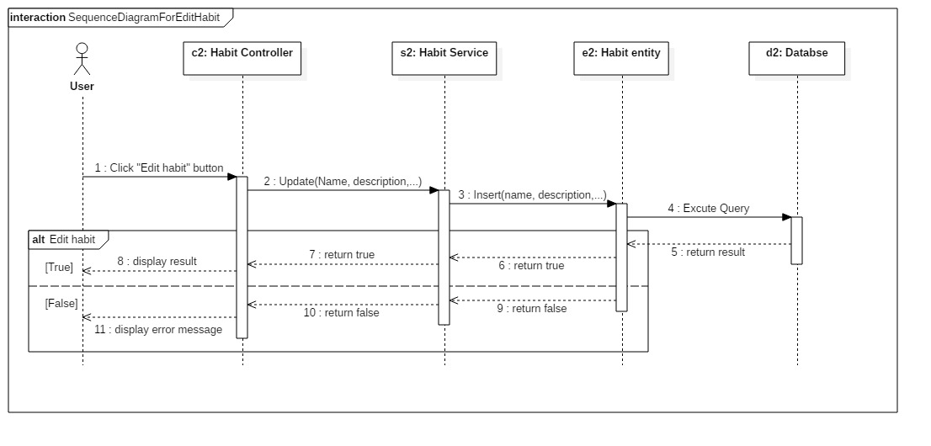

Figure - Sequence Diagram for edit habit <User>

* + 1. *Delete habit*

*Summary: this diagram show process of user deletes a habit*

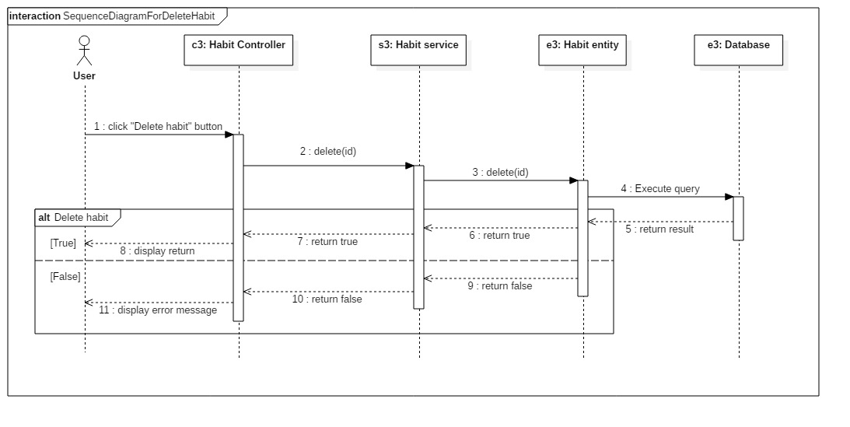

Figure - Sequence Diagram for add delete habit <User>

* 1. Activity diagram

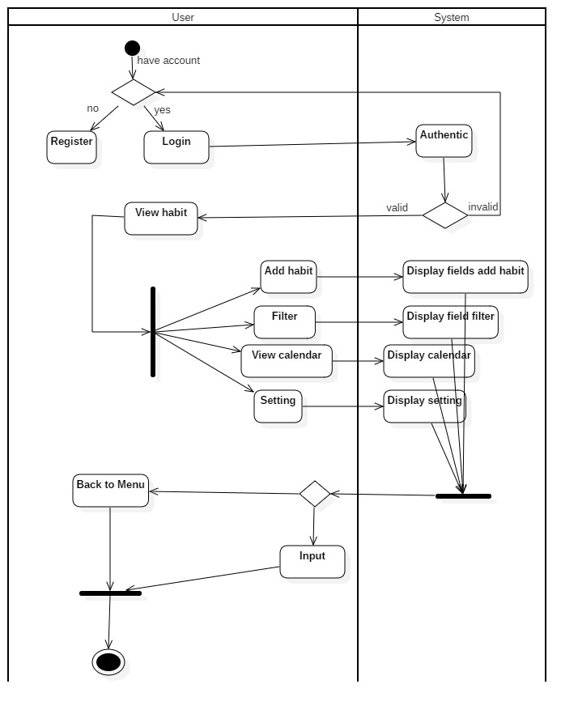

* 1. State machine diagram

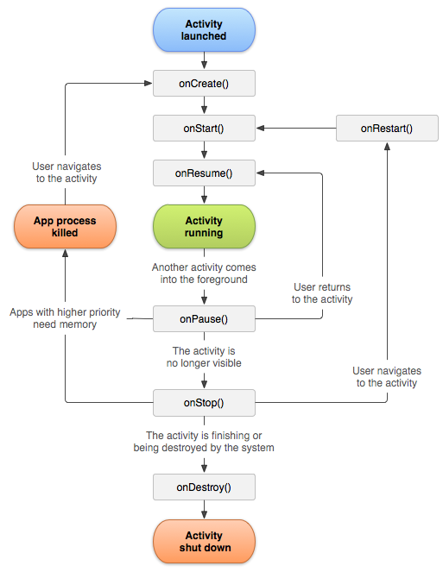

## Database Relationship Diagram



### Physical diagram

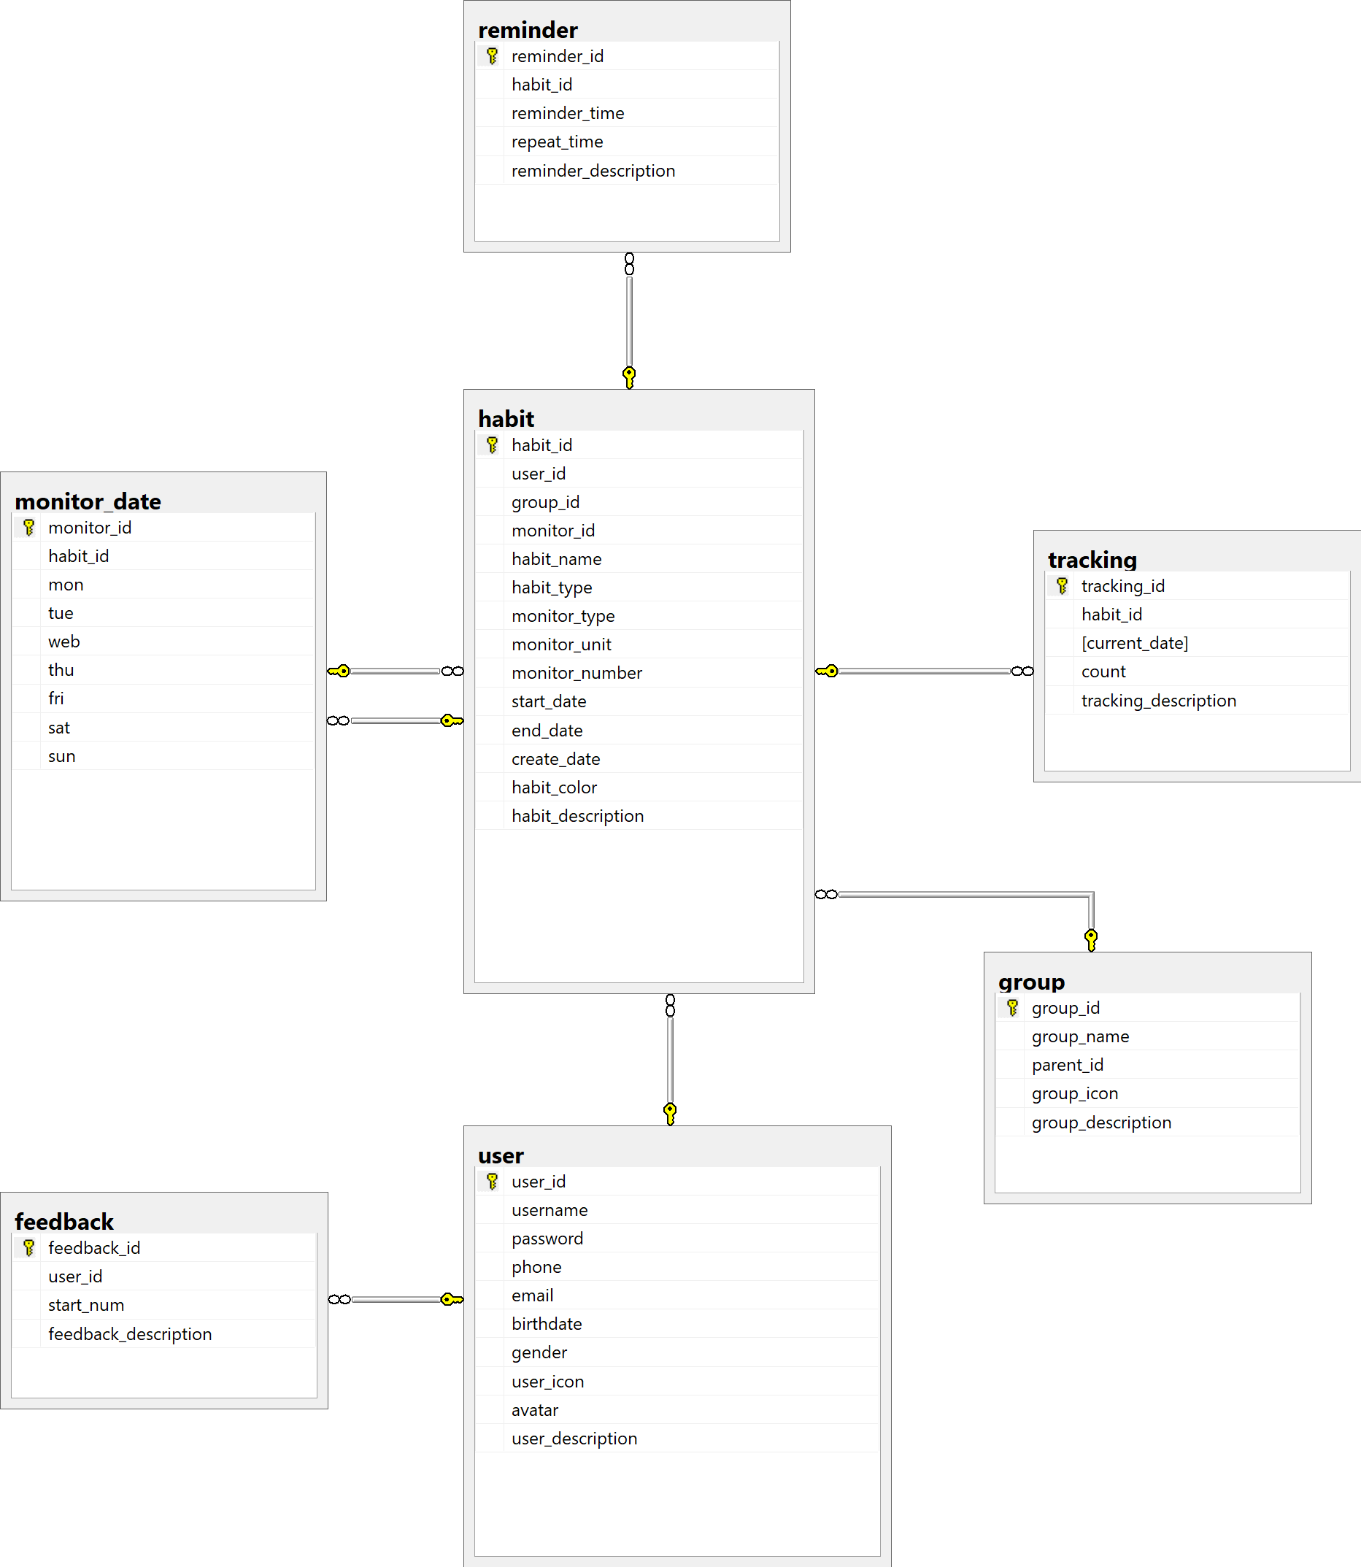

### Data dictionary

|  |  |
| --- | --- |
| **DATA DICTIONARY: DESCRIBE CONTENT OF ALL TABLES** | |
| **Table name** | **Description** |
| Account | Contains the account information |
| Work Order | Contains the work order information |
| WorkOrderRecord | Contains the information of a user that modified in work order |
| WorkOrderStatus | Contains the work order’s status information |
| WorkOrderCategory | Contains the work order’s category information |
| Priority | Contains the work order’s priority information |
| Equipment | Contains the equipment information |